**Class Assignment#4:**

**Question1:**

**Code:**

*/*  
Class Assignment: Checking the valid integer inputs   
*/  
  
import* java.util.*;  
*import* java.lang.*;  
*public class* ClassQ1{  
 *public static void* main(String[] args){  
 Scanner input = *new* Scanner(System.in);  
  
 *int* temp = 0;  
 *int* sum = 0;  
 *while*(temp < 10){  
 System.out.println("Enter values: ");  
 *try*{   
 *int* user = input.nextInt();  
 temp++;  
 }  
 *catch*(Exception ex){  
 String str = input.next();  
 System.out.println("Input is in-valid. Try Again!");  
  
 }  
  
 }  
 }  
}

**Output:**

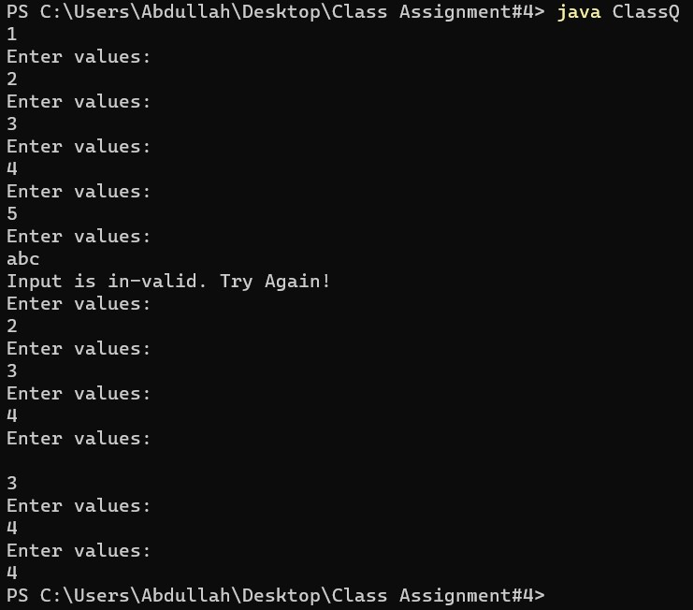

**Question2:**

**Code:**

*/*  
  
Class Assignment: Suming desired column elements   
*/  
  
import* java.util.*;  
*import* java.lang.*;  
*public class* ClassQ2{  
 *public static void* main(String[] args){  
 Scanner input = *new* Scanner(System.in);  
  
 *double*[][] matrix = *new double*[3][4];  
 System.out.println("Enter elements row by row:");  
 *for*(*int* row = 0; row < matrix.length; row++){  
 *for*(*int* col = 0; col < matrix[row].length; col++){  
 *double* user = input.nextDouble();  
 matrix[row][col] = user;   
 }  
 }  
 System.out.println("Enter the column index: ");  
 *int* index = input.nextInt();  
 System.out.println("Matrix is: ");  
 printMatrix(matrix);  
 System.out.println("Sum of elements at column " + index + " is: ");  
 System.out.println(sumColumn(matrix,index));  
  
 }  
 *public static double* sumColumn(*double*[][] m, *int* columnIndex){  
 *double* sum = 0;  
 *for*(*int* row = 0; row < m.length; row++){  
 *for*(*int* col = 0; col < m[row].length; col++){  
 *if*(col == columnIndex){   
 sum += m[row][col];   
 }  
 }  
 }  
 *return* sum;  
 }  
 *public static void* printMatrix(*double*[][] matrix){  
 System.out.println("--------------------------");  
 *for*(*int* row = 0; row < matrix.length; row++){  
 *for*(*int* col = 0; col < matrix[row].length; col++){  
 System.out.print(matrix[row][col] + " ");  
 }  
 System.out.println();  
 }  
 System.out.println("--------------------------");  
 }  
  
}

**Output:**

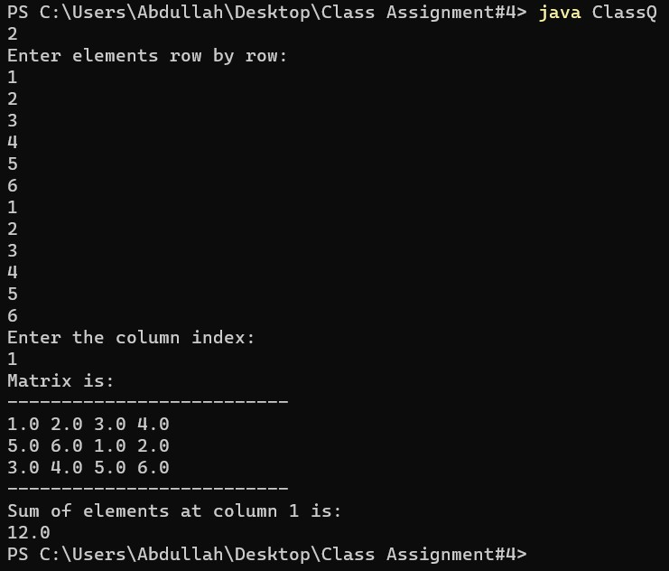

**Question3:**

**Code:**

*/*  
Class Assignment: summing diagonal elements   
*/  
  
import* java.util.*;  
*import* java.lang.*;  
*public class* ClassQ3{  
 *public static void* main(String[] args){  
 Scanner input = *new* Scanner(System.in);  
  
 *double*[][] matrix = *new double*[4][4];  
 System.out.println("Enter elements row by row:");  
 *for*(*int* row = 0; row < matrix.length; row++){  
 *for*(*int* col = 0; col < matrix[row].length; col++){  
 *double* user = input.nextDouble();  
 matrix[row][col] = user;   
 }  
 }  
 System.out.println("Matrix is: ");  
 printMatrix(matrix);  
 System.out.println("Sum of diagonal elements is: ");  
 System.out.println(sumMajorDiagonal(matrix));  
  
 }  
 *public static double* sumMajorDiagonal(*double*[][] m){  
 *double* sum = 0;  
 *for*(*int* row = 0; row < m.length; row++){  
 *for*(*int* col = 0; col < m[row].length; col++){  
 *if*(row == col){   
 sum += m[row][col];   
 }  
 }  
 }  
 *return* sum;  
 }  
 *public static void* printMatrix(*double*[][] matrix){  
 System.out.println("--------------------------");  
 *for*(*int* row = 0; row < matrix.length; row++){  
 *for*(*int* col = 0; col < matrix[row].length; col++){  
 System.out.print(matrix[row][col] + " ");  
 }  
 System.out.println();  
 }  
 System.out.println("--------------------------");  
 }  
  
}

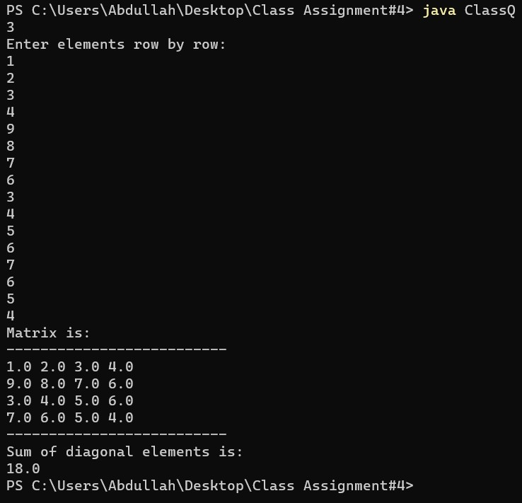**Output:**